**ASSIGNMENT-2**

1. Write a java program to find following using looping and decision making without function
   1. Sum of all digits of any numbers
2. import java.util.Scanner;
3. public class Assignment1_1{
4. public static void main(String[] args) {
5. Scanner sc=new Scanner(System.in);
6. int num,rem,sum=0;
7. System.out.println("Enter the number");
8. num=sc.nextInt();
9. while (num>0) {
10. rem=num%10;
11. sum+=rem;
12. num/=10;
13. }
14. System.out.println("The sum of the digit is :: "+sum);
15. }
16. }

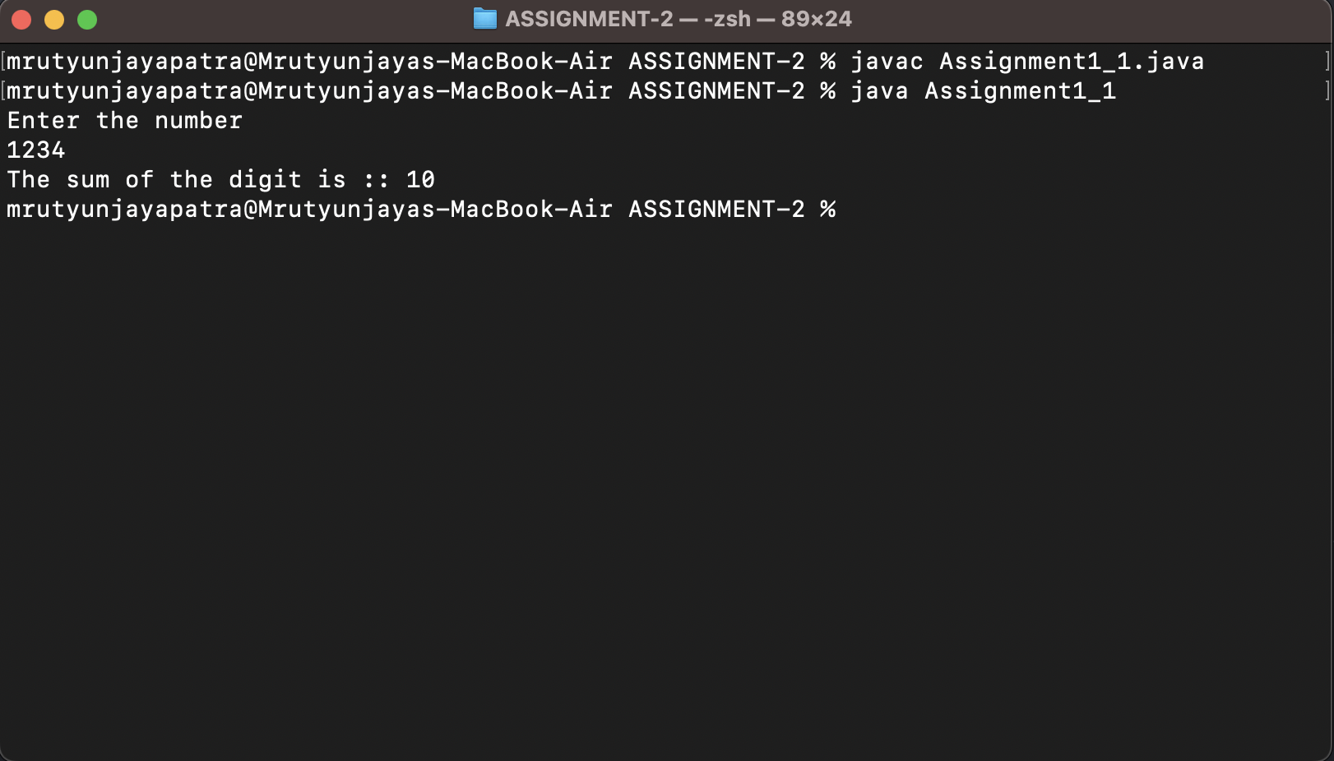Output :-

ii. Sum of all even digits of any number

import java.util.Scanner;

/*Sum of all even digits of any number */

public class Assignment1_2 {

public static void main(String[] args) {

Scanner sc=new Scanner(System.in);

int num,rem,sum=0;

System.out.println("Enter the number ");

num=sc.nextInt();

while(num>0){

rem=num%10;

if (rem%2==0) {

sum+=rem;

}

num/=10;

}

System.out.println("Sum of even digit is :: "+sum);

}

}

Output:-

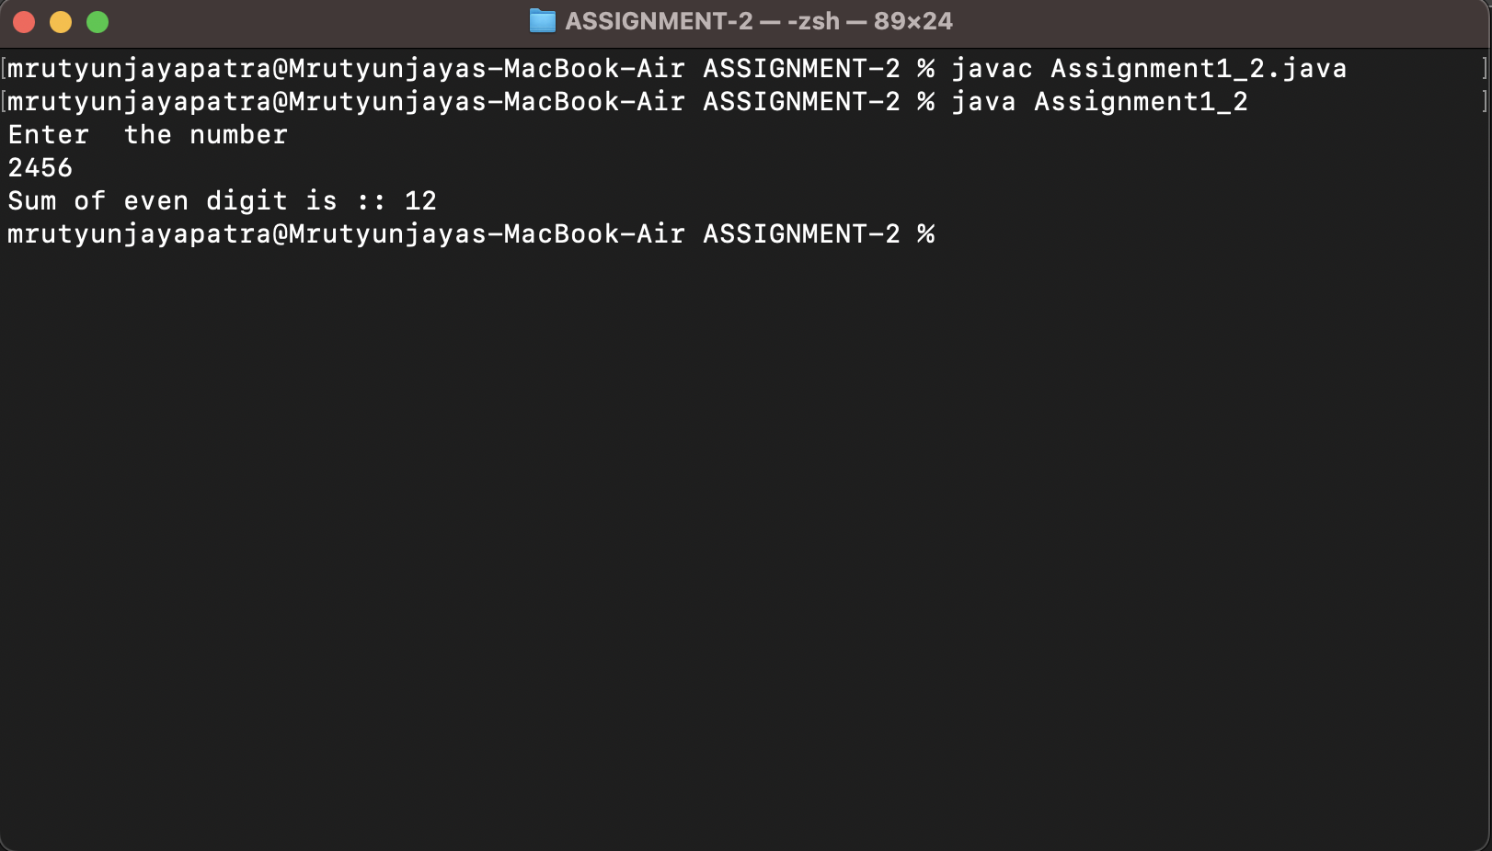

iii. Sum of all odd digits of any number

import java.util.Scanner;

/*Sum of all odd digits of any number */

public class Assignment1_3 {

public static void main(String[] args) {

Scanner sc=new Scanner(System.in);

int num,rem,sum=0;

System.out.println("Enter the number ");

num=sc.nextInt();

while(num>0){

rem=num%10;

if (rem%2!=0) {

sum+=rem;

}

num/=10;

}

System.out.println("Sum of odd digit is :: "+sum);

}

}

Output:-

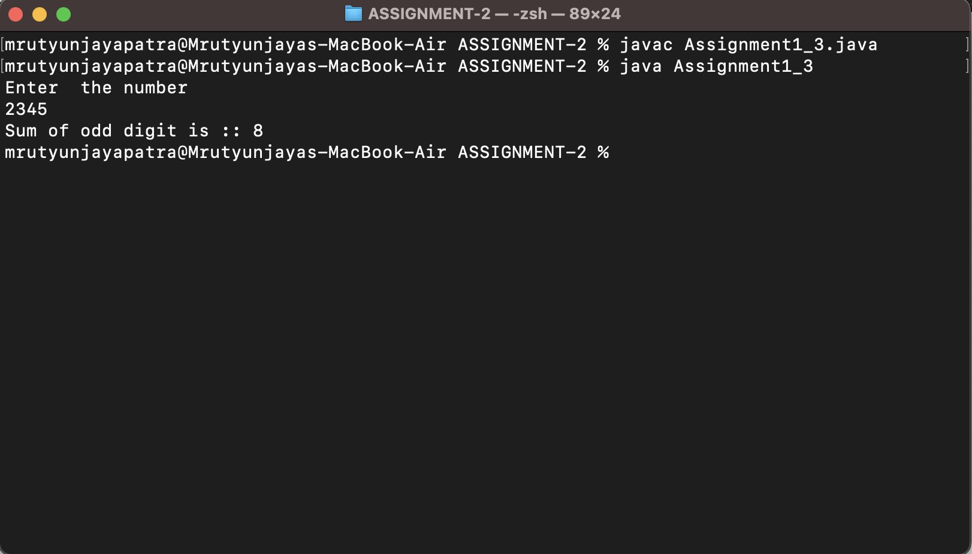

iv. Sum of all prime digits

import java.util.Scanner;

public class Assignment1_4 {

public static void main(String[] args) {

Scanner sc=new Scanner(System.in);

int num,rem,sum=0,count=0;

System.out.println("Enter the number ");

num=sc.nextInt();

while (num>0) {

rem=num%10;

for(int i=1;i<=rem;i++){

if (rem%i==0) {

count++;

}

}

if (count==2) {

sum+=rem;

}

count=0;

num/=10;

}

System.out.println("The sum of prime digit is :: "+sum);

}

}

Output :-

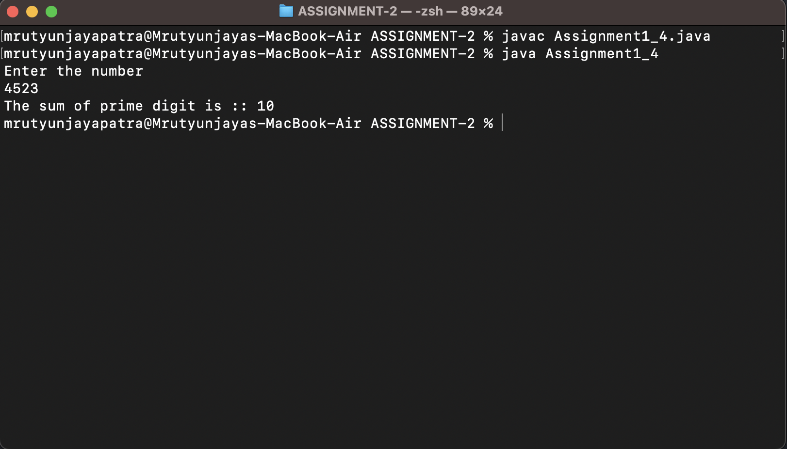

v. Difference between average of all even digits except divisible by 4 and average of all odd digits except divisible by 3

import java.util.Scanner;

public class Assignment1_5 {

public static void main(String[] args) {

int num,rem,sum1=0,sum2=0,count1=0,count2=0;

Scanner sc=new Scanner(System.in);

System.out.println("Enter the number");

num=sc.nextInt();

while (num>0) {

rem=num%10;

if (rem%2==0 && rem%4!=0) {

sum1+=rem;

count1++;

}else if (rem%2!=0 && rem%3!=0) {

sum2+=rem;

count2++;

}

num/=10;

}

System.out.println("Difference is :: "+((sum1/count1)-(sum2/count2)));

}

}

Output:-

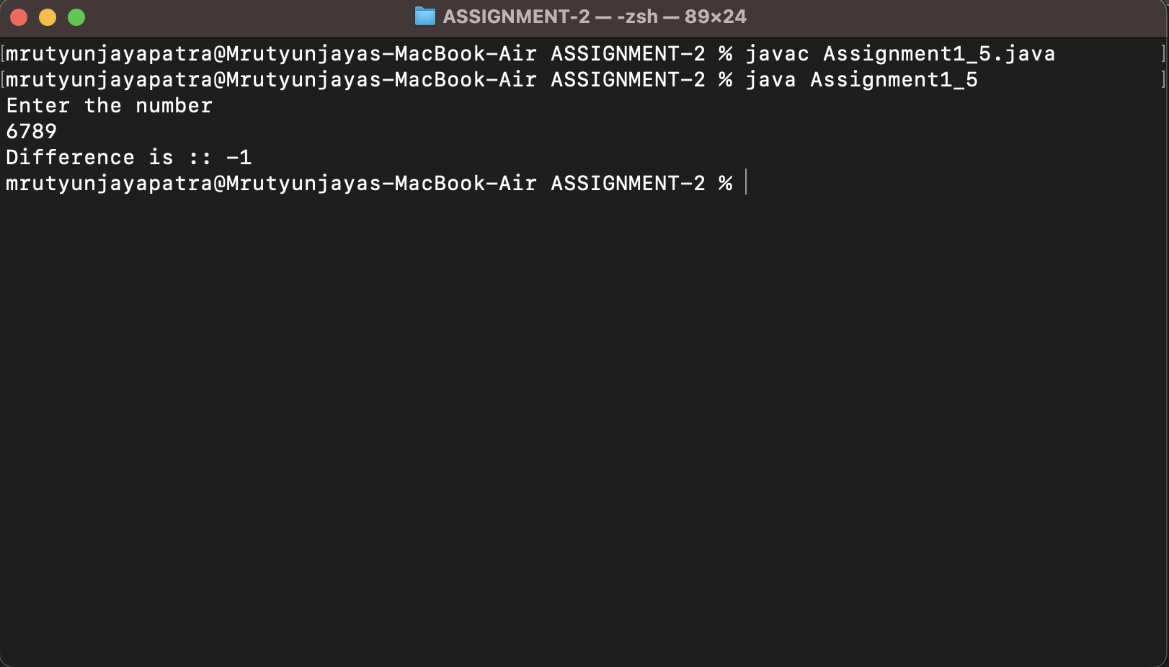

vii. Sum of product of consecutive digits of any digit number

import java.util.Scanner;

public class Assignment1_7 {

public static void main(String[] args) {

Scanner sc=new Scanner(System.in);

int num,rem,prod=1;

System.out.println("Enter a number ");

num=sc.nextInt();

while (num>0) {

rem=num%10;

prod*=rem;

num/=10;

}

System.out.println("Product of consecutive digit is :: "+prod);

}

}

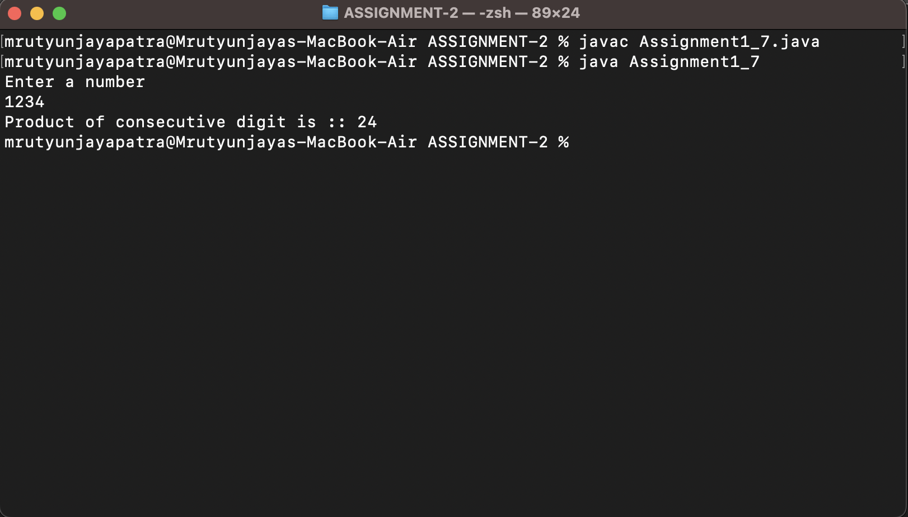Output:-

viii. Sum of product of consecutive even digits of any digit number

import java.util.Scanner;

public class Assignment1_8 {

public static void main(String[] args) {

Scanner sc=new Scanner(System.in);

int num,rem1,rem2,sum=0;

System.out.println("Enter the number");

num=sc.nextInt();

while (num>0) {

rem1=num%10;

rem2=(num/10)%10;

if (rem1%2==0 && rem2%2==0) {

sum+=rem1*rem2;

}

num/=10;

}

System.out.println("Sum of product of consecutive even digits of any digit number :: "+sum);

}

}

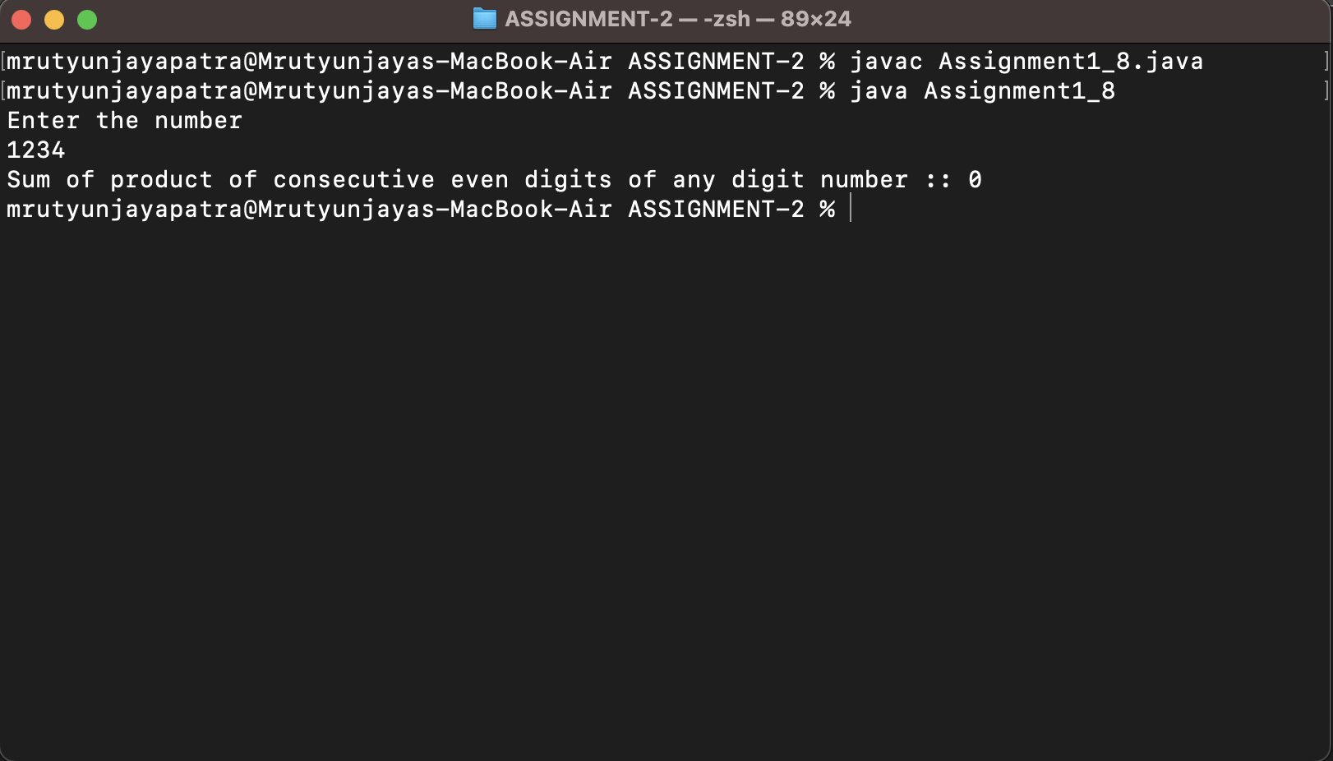Output:-

ix. Sum of product of consecutive odd digits of any digit number

import java.util.Scanner;

public class Assignment1_9 {

public static void main(String[] args) {

Scanner sc=new Scanner(System.in);

int num,rem1,rem2,sum=0;

System.out.println("Enter the number");

num=sc.nextInt();

while (num>0) {

rem1=num%10;

rem2=(num/10)%10;

if (rem1%2!=0 && rem2%2!=0) {

sum+=rem1*rem2;

}

num/=10;

}

System.out.println("Sum of product of consecutive odd digits of any digit number :: "+sum);

}

}

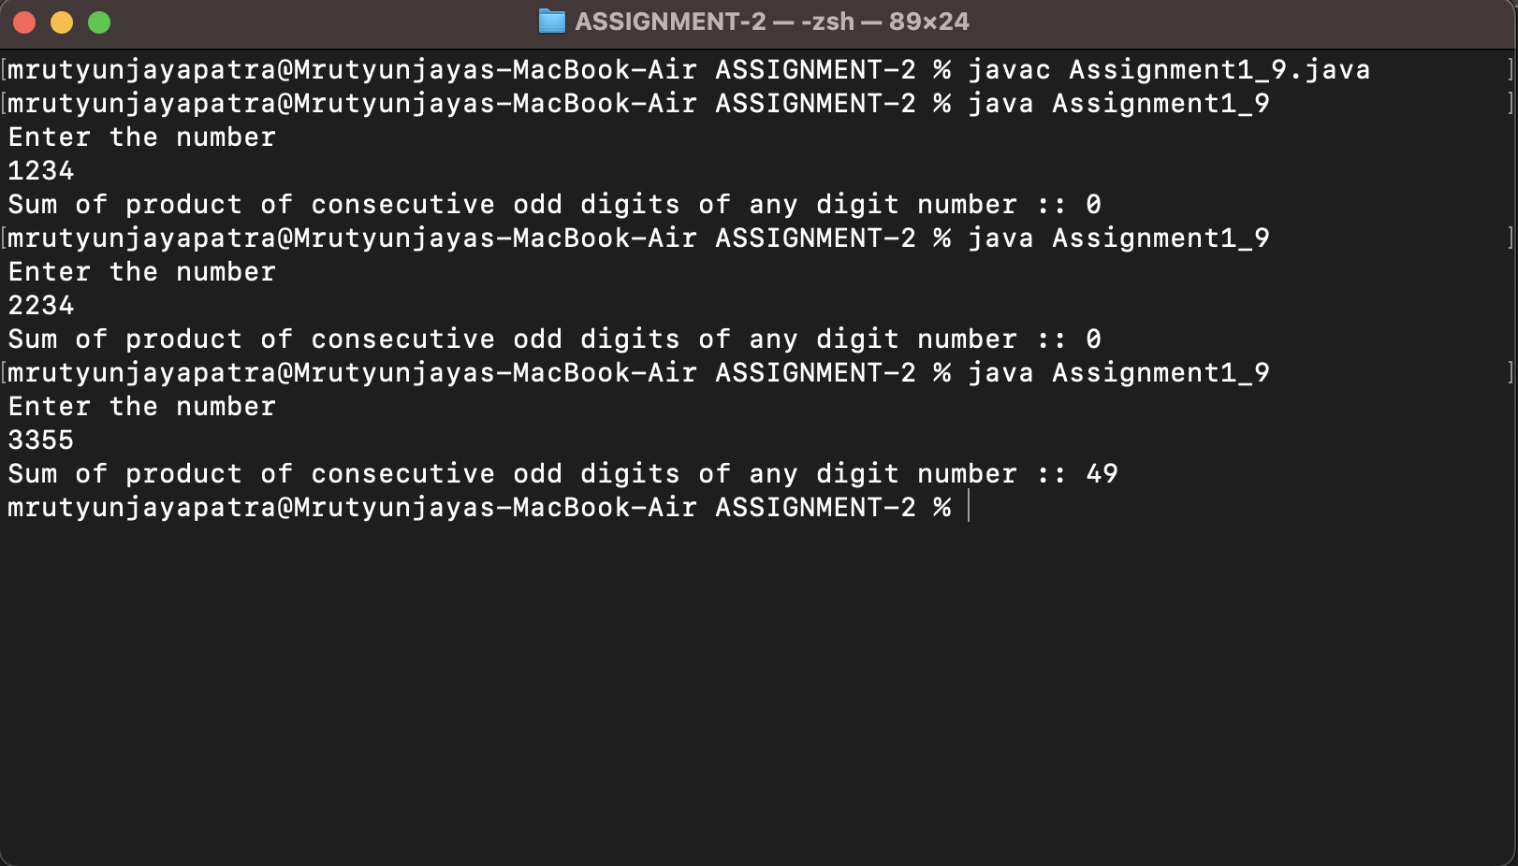

x. Sum of product of consecutive prime digits of any digit number

import java.util.Scanner;

public class Assignment1_10 {

public static void main(String[] args) {

Scanner sc=new Scanner(System.in);

int num,rem1,rem2,sum=0,prod=1;

System.out.println("Enter the number ");

num=sc.nextInt();

while (num>0) {

rem1=num%10;

rem2=(num/10)%10;

if ((rem1==2 || rem1==3 || rem1==5 || rem1==7) && (rem2==2 || rem2==3 || rem2==5 || rem2==7)) {

sum+=rem1*rem2;

}

num/=10;

}

System.out.println("Sum of product of consecutive prime digits of any digit number"+sum);

}

}

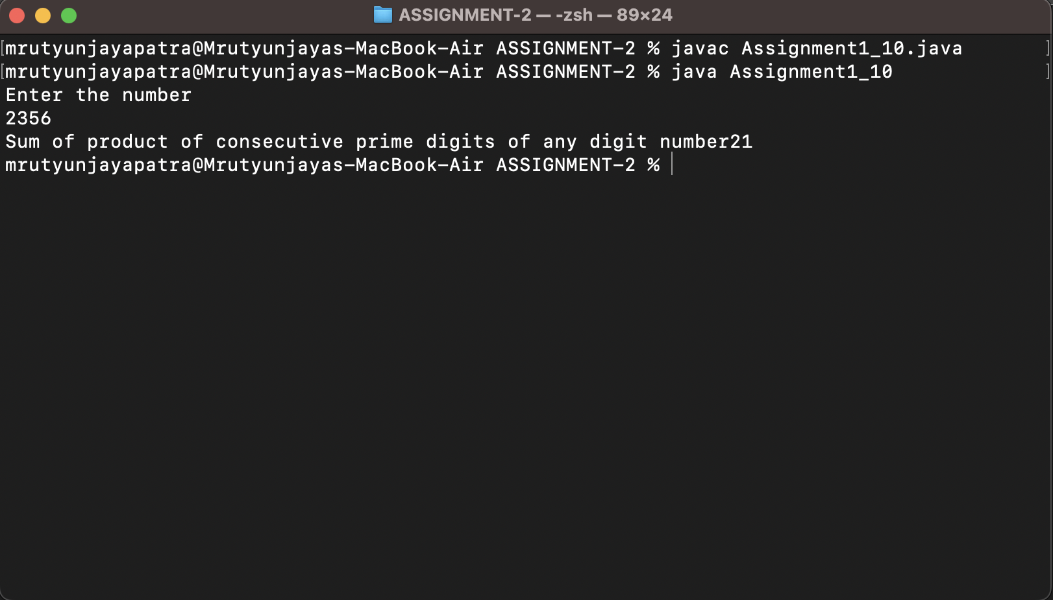

xi. Difference between Sum of product of consecutive even digits except 2 and 6 and Sum of product of consecutive odd digits except 3 and 7 of any digit number

import java.util.Scanner;

public class Assignment1_11 {

public static void main(String[] args) {

Scanner sc=new Scanner(System.in);

int num,rem1,rem2,sum1=0,sum2=0;

System.out.println("Enter the number");

num=sc.nextInt();

while (num>0) {

rem1=num%10;

rem2=(num/10)%10;

if ((rem1%2==0 && rem2%2==0) && (rem1!=2 && rem1!=6) && (rem2!=2 && rem2!=6)) {

sum1+=rem1*rem2;

}else if ((rem1%2!=0 && rem2%2!=0 )&& (rem1!=3 && rem1!=7) && (rem2!=3 && rem2!=7)) {

sum2+=rem1*rem2;

}

num/=10;

}

System.out.println("Sum of even digit is "+sum1);

System.out.println("Sum of odd digit is "+sum2);

}

}

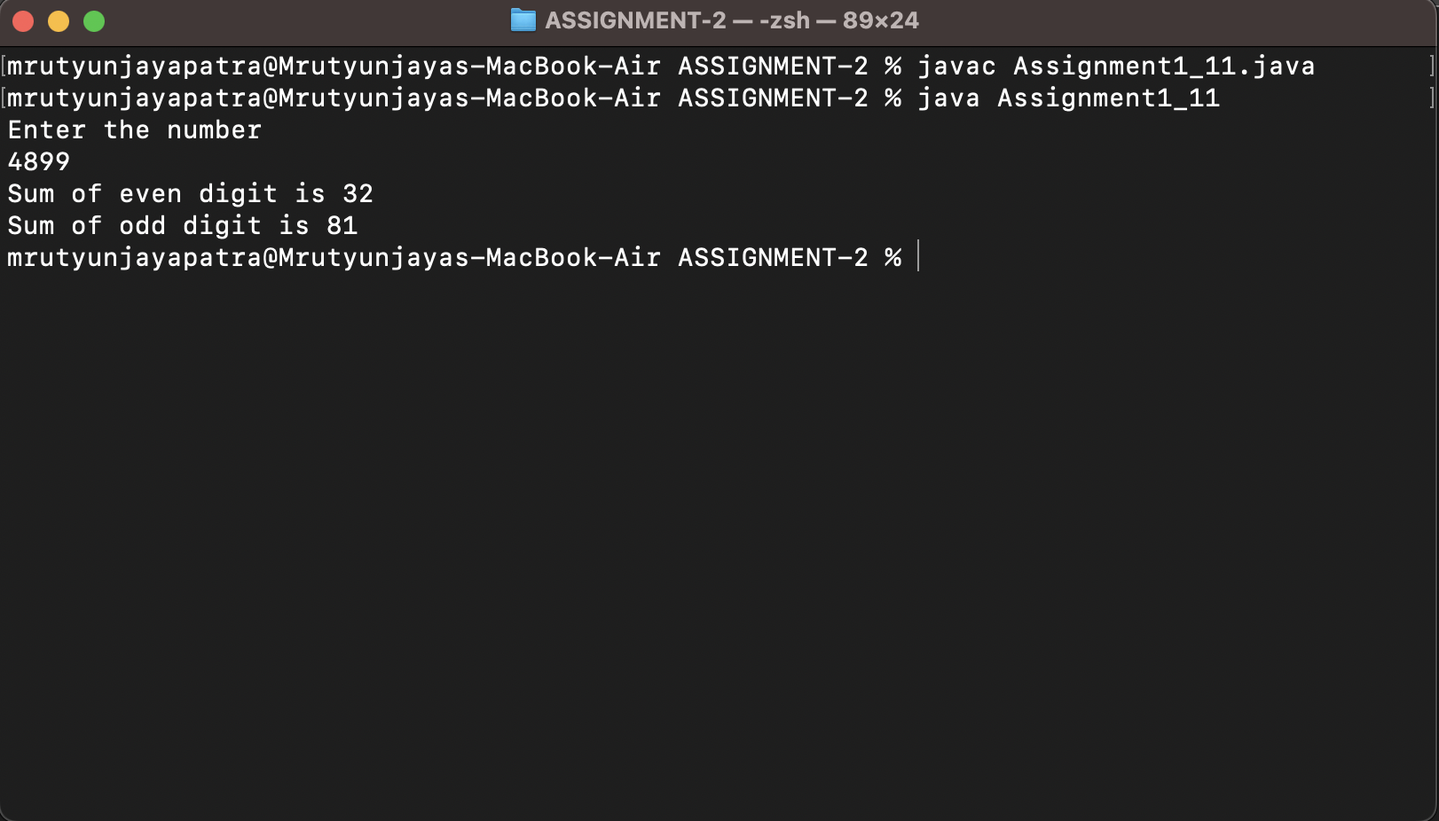

1. Write a java program to find sum of product of corresponding digits of two any digit number Such as n=1234 m=7896 output=6*4+9*3+8*2+7*1.

import java.util.Scanner;

public class Assignment2 {

public static void main(String[] args) {

Scanner sc = new Scanner(System.in);

int m, n, sum = 0, rem1, rem2;

System.out.println("Enter the first number (m)");

m = sc.nextInt();

System.out.println("Enter the second number (n)");

n = sc.nextInt();

while (m > 0 && n > 0) {

rem1 = m % 10;

rem2 = n % 10;

sum+=(rem1*rem2);

m/=10;

n/=10;

}

System.out.println("Sum of product of corresponding digits of two any digit number is "+sum);

}

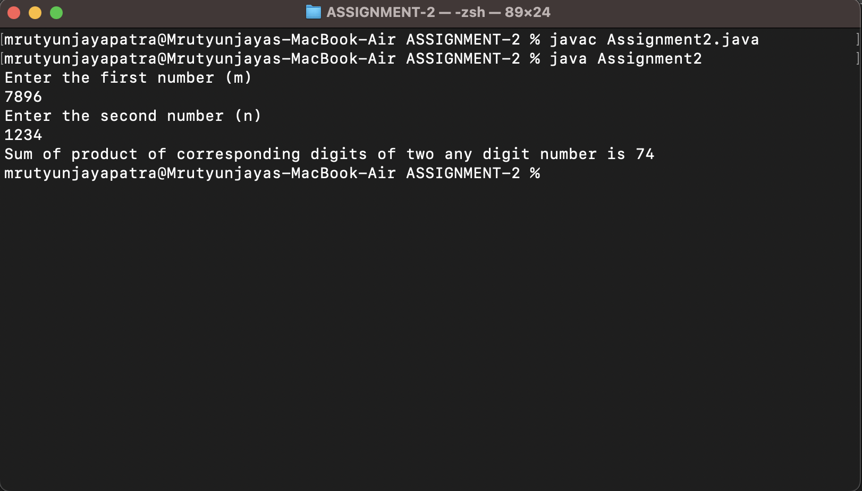}

1. Write a java program to find sum of product of corresponding even digits of first any digit number and corresponding odd digit of any digit number Such as n=1234 m=4567 output=4*7+2*5

import java.util.Scanner;

public class Assignment3 {

public static void main(String[] args) {

Scanner sc = new Scanner(System.in);

int m, n, sum = 0, prod = 1, rem1, rem2;

System.out.println("Enter the first number (m)");

m = sc.nextInt();

System.out.println("Enter the second number (n)");

n = sc.nextInt();

while (m > 0 && n > 0) {

rem1 = m % 10;

rem2 = n % 10;

if ((rem1 % 2 == 0 && rem2 % 2 != 0) ) {

sum += (rem1 * rem2);

}

m /= 10;

n /= 10;

}

System.out.println("Sum of product of corresponding digits even digits of first any digit number and corresponding odd digit of any digit number is " + sum);

}

}

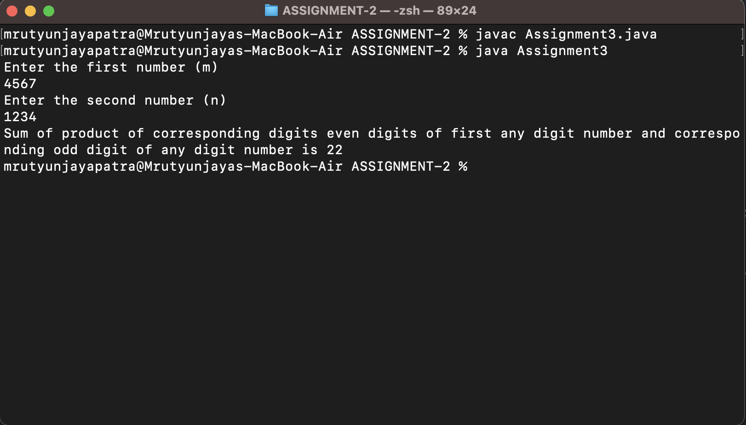

1. Write a java program to compute following series and take input x and n
   1. 1-x2/2! + x3/3!-x4/4!+------+xn/n!

import java.util.Scanner;

public class Assignment4_1 {

public static void main(String[] args) {

Scanner sc=new Scanner(System.in);

int x,n,fact=1;

double sum=1;

boolean check=false;

System.out.println("Enter the value of x ");

x=sc.nextInt();

System.out.println("Enter the value of n ");

n=sc.nextInt();

for (int i = 2; i <=n; i++) {

for (int j = 1; j <=i; j++) {

fact*=j;

}

if (check) {

sum+=(Math.pow(x, i)/fact);

check=false;

}else{

sum-=(Math.pow(x, i)/fact);

check=true;

}

fact=1;

}

System.out.println(sum);

}

}

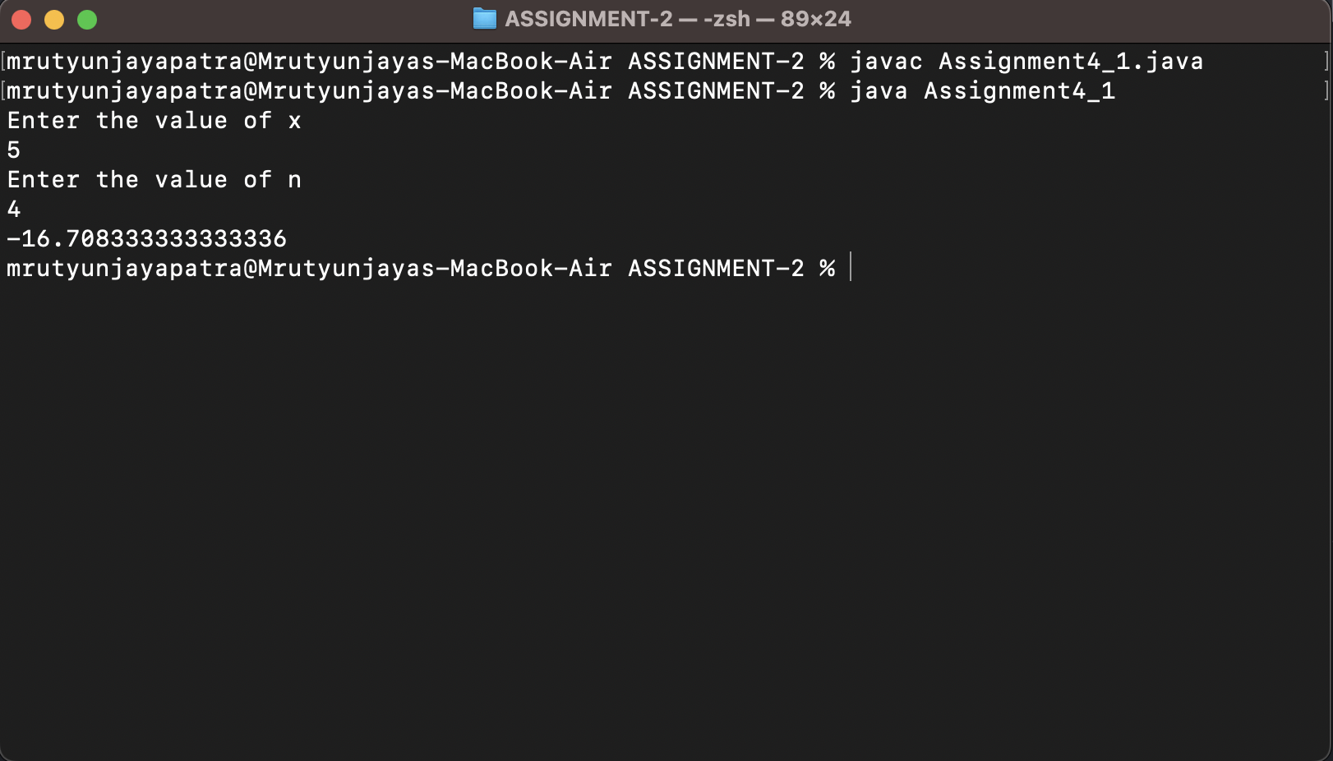

* 1. x-x3/3! + x5/5!-x7/7!+------+xn/n!

import java.util.Scanner;

public class Assignment4_2 {

public static void main(String[] args) {

Scanner sc = new Scanner(System.in);

int x, n, fact = 1;

boolean check=false;

double sum = 0;

System.out.println("Enter the value of x");

x = sc.nextInt();

System.out.println("Enter the value of n");

n = sc.nextInt();

sum = x;

for (int i = 3; i <= n; i =i+2) {

for (int j = 1; j <= i; j++) {

fact = fact * j;

}

if (check) {

sum += Math.pow(x, i) / fact;

check=false;

} else {

sum -= Math.pow(x, i) / fact;

check=true;

}

fact = 1;

}

System.out.println(sum);

}

}

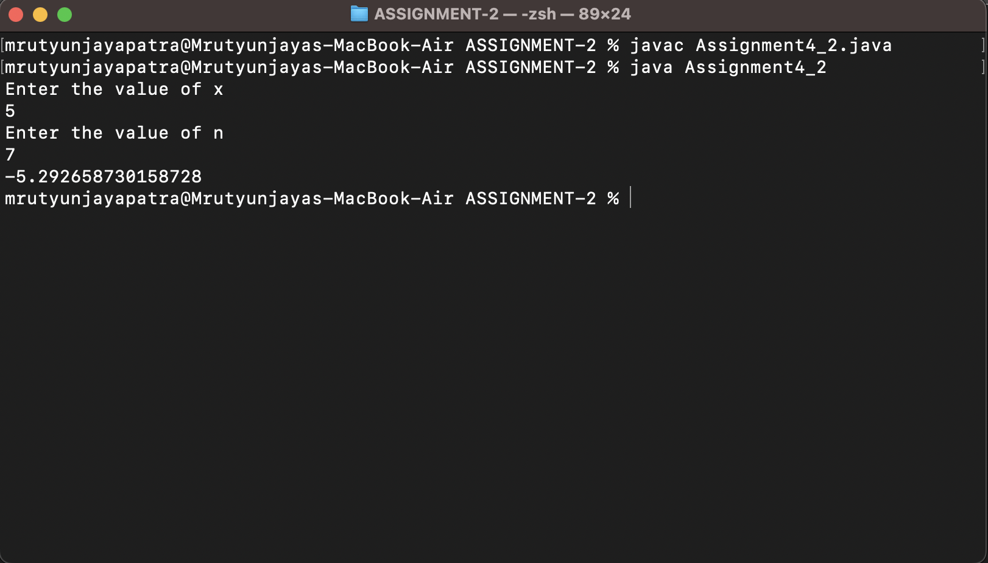

* 1. 1+x2/2! + x4/4!+x6/6!+------+xn/n!

import java.util.Scanner;

/*1+x2/2! + x4/4!+x6/6!+------+xn/n! */

public class Assignment4_3 {

public static void main(String[] args) {

Scanner sc = new Scanner(System.in);

int x, n, fact = 1, count = 0;

double sum = 1;

System.out.println("Enter the value of x");

x = sc.nextInt();

System.out.println("Enter the value of n");

n = sc.nextInt();

for(int i=2;i<=n;i=i+2){

for (int j = 1; j <=i; j++) {

fact=fact*i;

}

sum+=Math.pow(x, i)/fact;

fact=1;

}

System.out.println(sum);

}

}

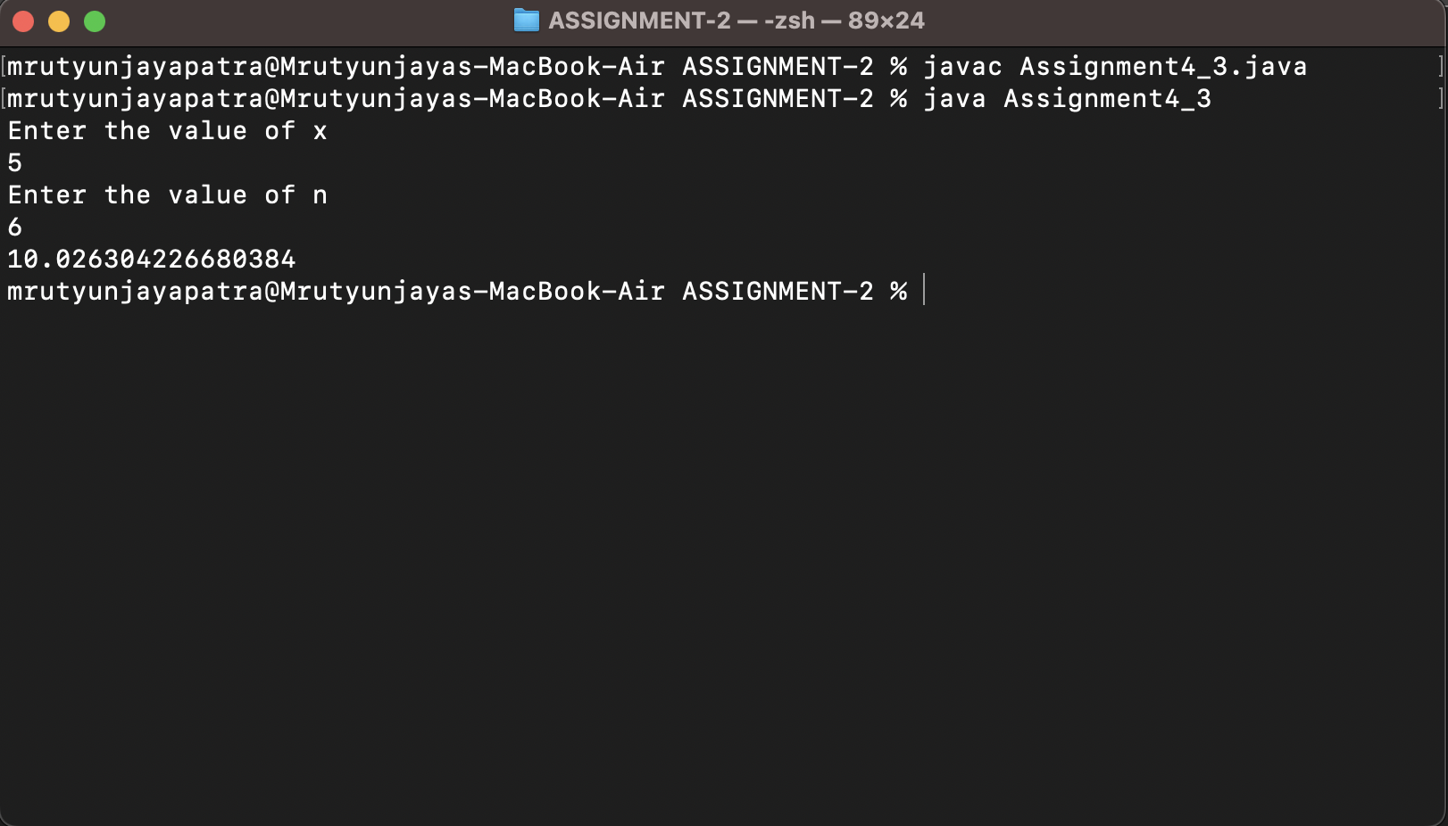

* 1. x-x3/3! + x5/5!-x7/7!+x11/11!------+xn/n!

import java.util.Scanner;

/*x-x3/3! + x5/5!-x7/7!+x11/11!------+xn/n! */

public class Assignment4_4 {

public static void main(String[] args) {

Scanner sc=new Scanner(System.in);

int x,n,fact=1;

double sum;

System.out.println("Enter the value of x");

x=sc.nextInt();

System.out.println("Enter the value of n");

n=sc.nextInt();

int count=0;

boolean check=false;

sum=x;

for (int i = 3; i <=n; i--) {

count=0;

for (int j = 1; j <=i; j++) {

if (i%j==0) {

count++;

}

}

if (count==2) {

for(int k=1;k<=i;k++){

fact=fact*k;

}

if (check) {

sum+=Math.pow(x, i)/fact;

fact=1;

check=false;

}else {

sum-=Math.pow(x, i)/fact;

fact=1;

check=true;

}

}

}

System.out.println(sum);

}

}

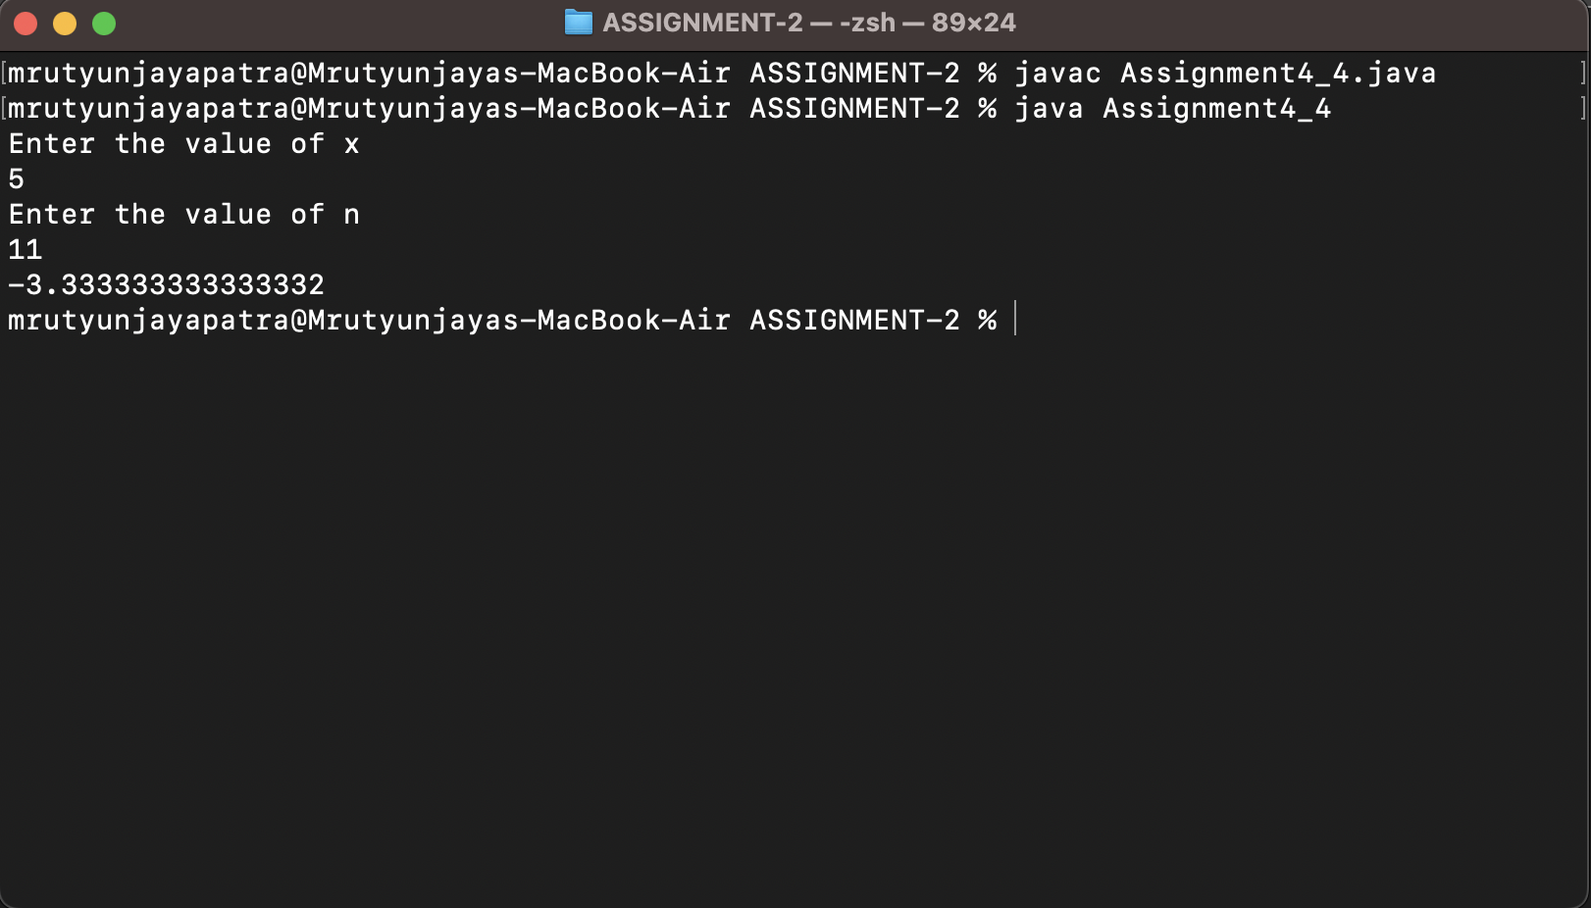

1. Write a java program compute following series and take a numbers num as input

x-x3/3! + x5/5!-x7/7!+------+xn/n! where x=sum of all even digits except 2 and 8 and n= sum of all odd digits except 1 and 3

import java.util.Scanner;

public class Assignment5 {

public static void main(String[] args) {

Scanner sc=new Scanner(System.in);

int x=0,n=0,num,fact=1,rem,count=0;

double sum;

System.out.println("Enter the number ");

num=sc.nextInt();

while (num>0) {

rem=num%10;

if (rem%2==0 && rem!=2 && rem!=8) {

x+=rem;

}else if(rem%2!=0 && rem!=1 && rem!=3){

n+=rem;

}

num/=10;

}

sum=x;

boolean check=false;

for (int i = 3; i<=n; i--) {

count=0;

for (int j = 1; j <=i; j++) {

if (i%j==0) {

count++;

}

}

if (count==2) {

for(int k=1;k<=i;k++){

fact=fact*k;

}

if (check) {

sum+=Math.pow(x, i)/fact;

fact=1;

check=false;

}else {

sum-=Math.pow(x, i)/fact;

fact=1;

check=true;

}

}

}

System.out.println(sum);

System.out.println("Assignment5.main()");

}

}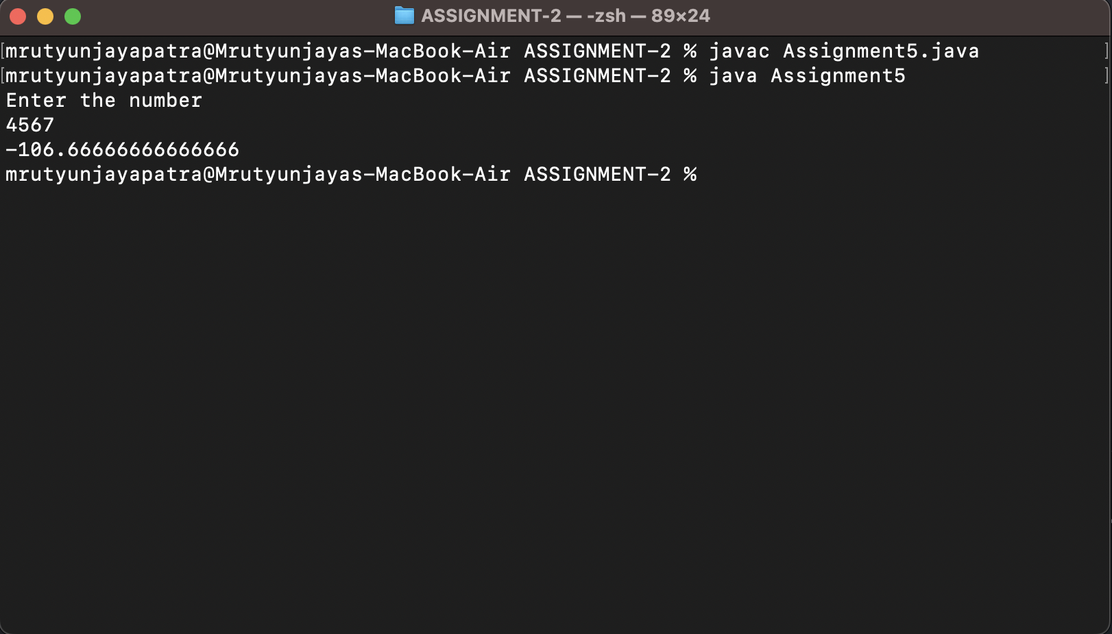

1. Write a java program to check weather the given number is palindrome and prime or not?

import java.util.Scanner;

public class Assignment6 {

public static void main(String[] args) {

int r, sum = 0, temp;

int n ;

Scanner sc=new Scanner(System.in);

System.out.println("Enter the number");

n=sc.nextInt();

temp = n;

while (temp > 0) {

r = temp % 10; // getting remainder

sum = (sum * 10) + r;

temp = temp / 10;

}

if (n == sum)

System.out.println("palindrome number ");

else

System.out.println("not palindrome");

int count=0;

for(int i=1;i<=n;i++){

if (n%i==0) {

count++;

}

}

if(count==2){

System.out.println("It is a prime number");

}else{

System.out.println("It is not a prime number");

}

}

}

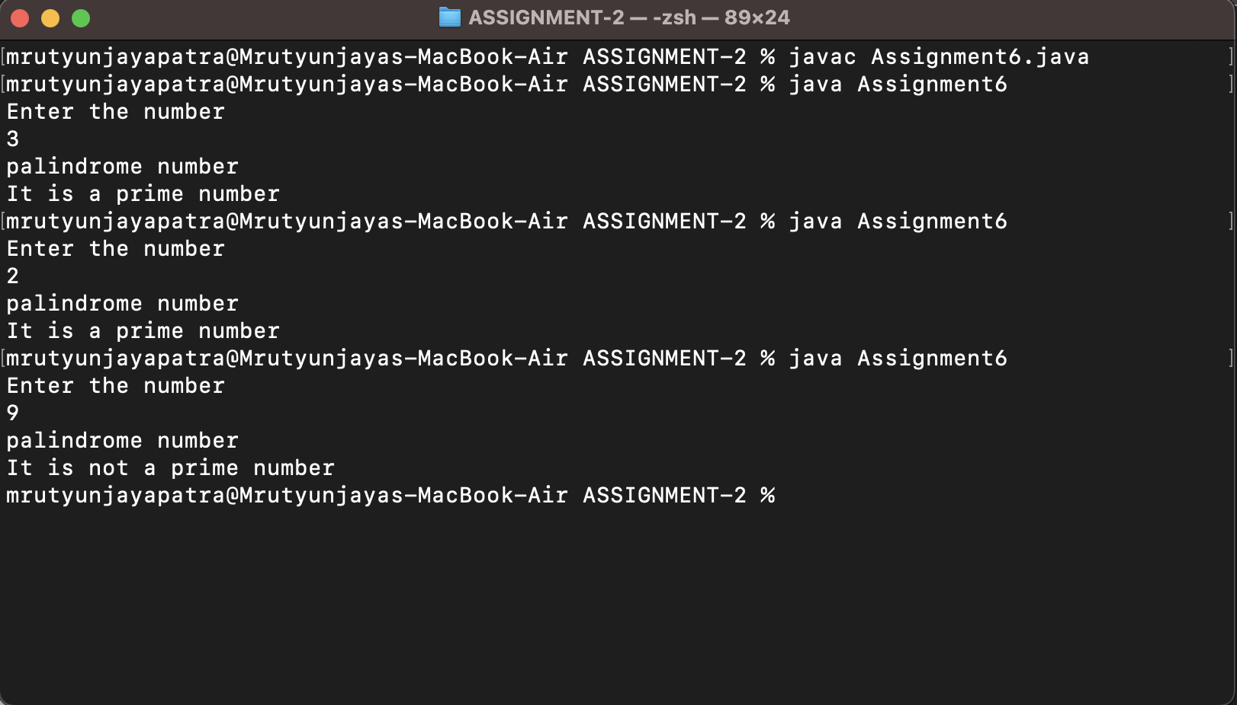

1. Write a java program to find factorial of a number using while loop, do while loop and for loop all in one program?[hint use switch block]?

import java.util.Scanner;

public class Assignment7 {

public static void main(String[] args) {

Scanner sc=new Scanner(System.in);

int num,fact=1,choice;

System.out.println("Enter the number ");

num=sc.nextInt();

System.out.println("Enter the choice Press\n1-Using for loop.\n2-Using while loop\n3-Using do while loop");

choice=sc.nextInt();

switch (choice) {

case 1:

for (int i = 1; i <=num; i++) {

fact*=i;

}

System.out.println("Factorial of "+num+" is "+fact);

break;

case 2:

int i=1;

while (i<=num) {

fact*=i;

i++;

}

System.out.println("Factorial of "+num+" is "+fact);

break;

case 3:

i=1;

do {

fact=fact*i;

i++;

} while (i<=num);

System.out.println("Factorial of "+num+" is "+fact);

break;

default:

System.out.println("Invalid Choice !!");

break;

}

}

}

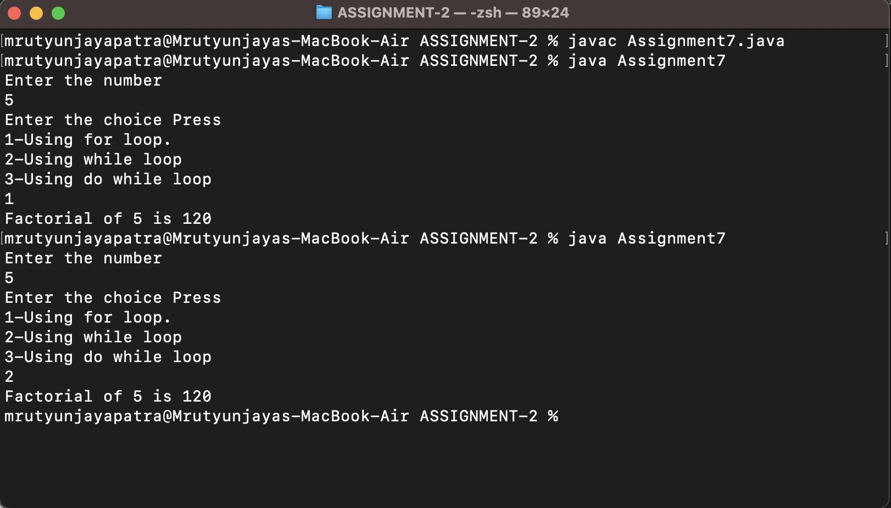

1. Write a program to find following data of student using mark of four subjects like C, C++, Java, and Python. Mark of 4 subjects will be accepted at the run time and credit of all the mentioned subject is 3?

a) Grade of 4 subjects?  
b) Total Mark and %age of mark secured by Students? c) SGPA of Student?

1. Write a program to find factorial of difference between greatest and smallest number among 3 numbers?

import java.util.Scanner;

public class Assignment9 {

public static void main(String[] args) {

int num,n1,n2,n3,fact=1,largest,smallest;

Scanner sc=new Scanner(System.in);

System.out.println("Enter three number");

n1=sc.nextInt();

n2=sc.nextInt();

n3=sc.nextInt();

largest=(n1>n2)?(n1>n3)?n1:n3:(n2>n3)?n2:n3;

smallest=(n1<n2)?(n1<n3)?n1:n3:(n2<n3)?n2:n3;

num=largest-smallest;

for (int i = 1; i <=num; i++) {

fact*=i;

}

System.out.println("Factorial of "+num+" is :: "+fact);

}

}

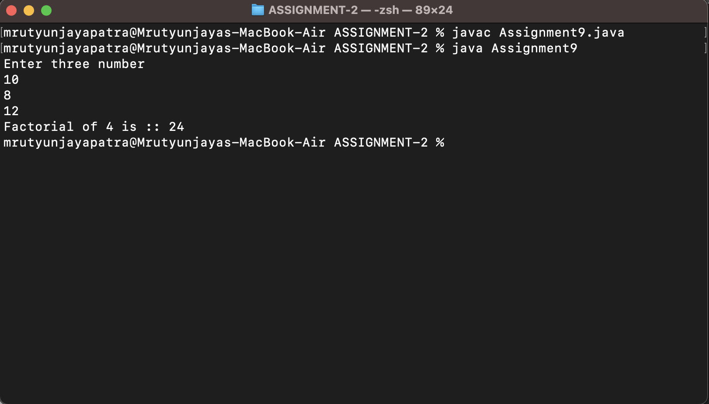

1. Write a program to generate Fibonacci series up to n terms? Value of n will be accepted from user?

import java.util.Scanner;

public class Assignment10 {

public static void main(String[] args) {

Scanner sc=new Scanner(System.in);

int num,fib1=0,fib2=1,fib3=fib1+fib2;

System.out.println("Enter the number");

num=sc.nextInt();

System.out.print("Series is :: \t"+fib1+"\t"+fib2);

while (num>2) {

fib3=fib1+fib2;

System.out.print("\t"+fib3);

fib1=fib2;

fib2=fib3;

num--;

}

}

}

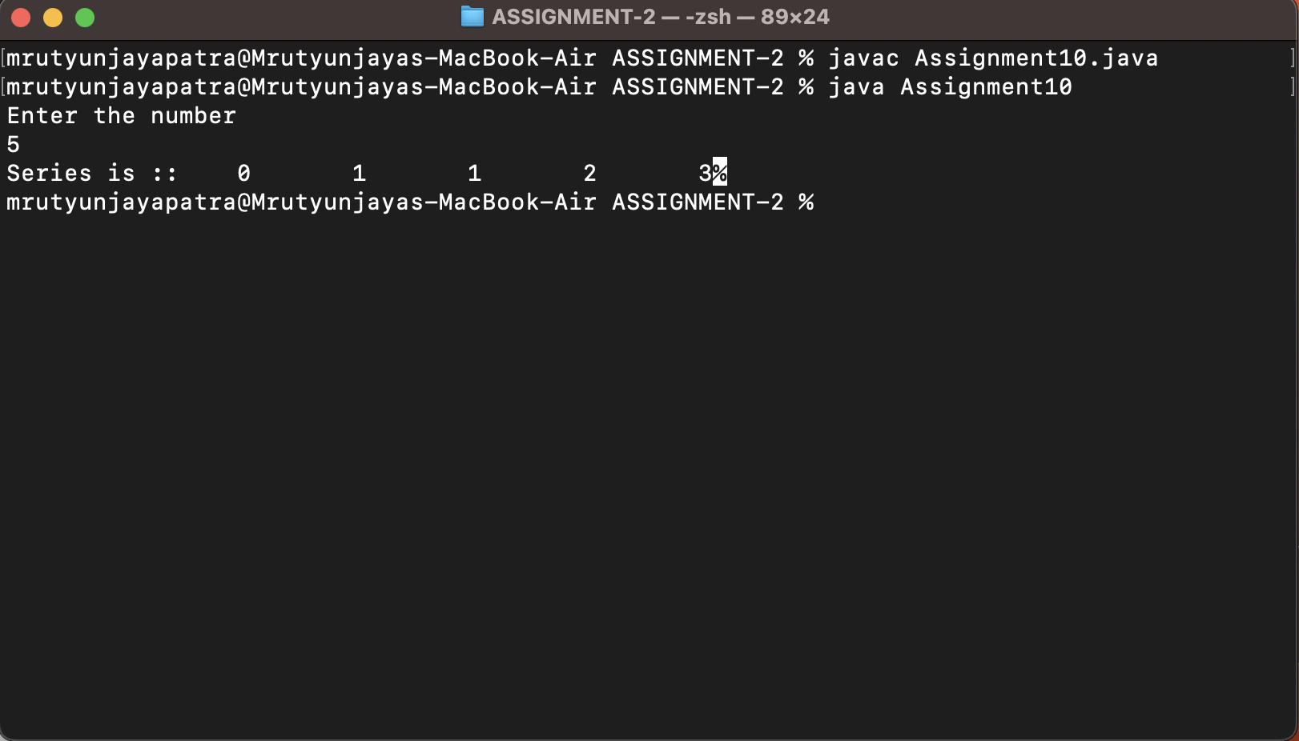

1. Write a program to perform following using the numbers in between 23 to 249? a) find number of even numbers that ends with 0 and 4?
2. import java.rmi.Remote;
3. public class Assignment11_1 {
4. public static void main(String[] args) {
5. int rem,count=0;
6. for (int i = 24; i < 249; i++) {
7. rem=i%10;
8. if (rem==0 || rem==4) {
9. count++;
10. }
11. }
12. System.out.println("The number of even number that ends with 0 and 4 is "+count);
13. }
14. }

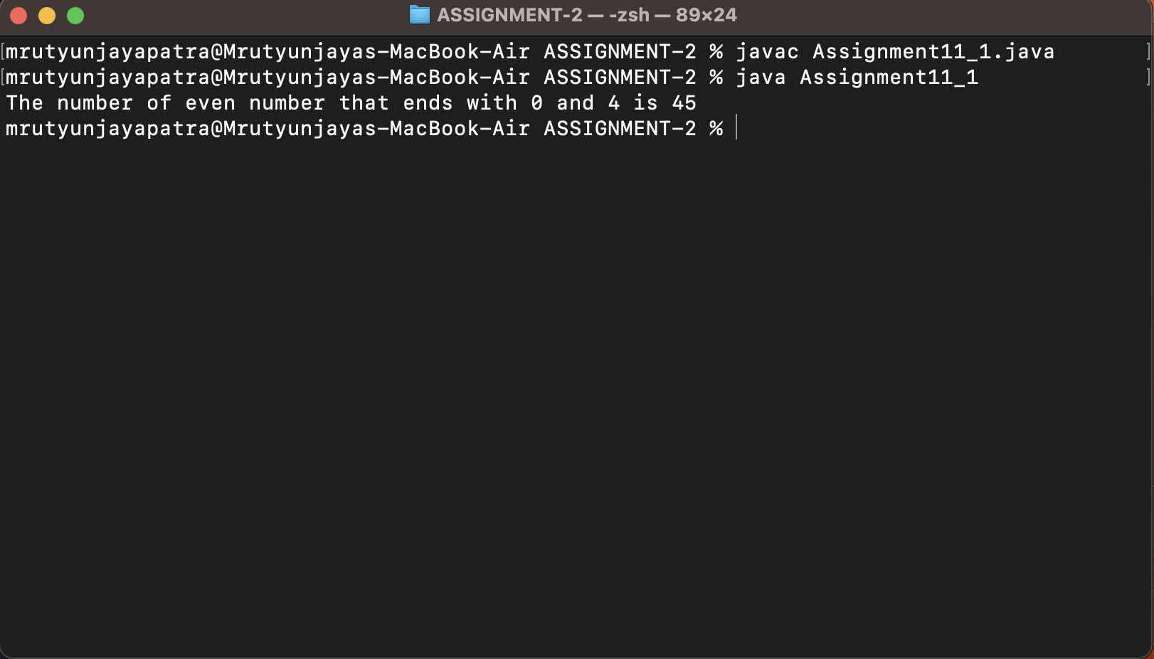

b) find number of odd numbers that ends with 5 and 7?

public class Assignment11_2 {

public static void main(String[] args) {

int rem,count=0;

for (int i = 24; i < 249; i++) {

rem=i%10;

if (rem==5 || rem==7) {

count++;

}

}

System.out.println("The number of odd number that ends with 5 and 7 is "+count);

}

}

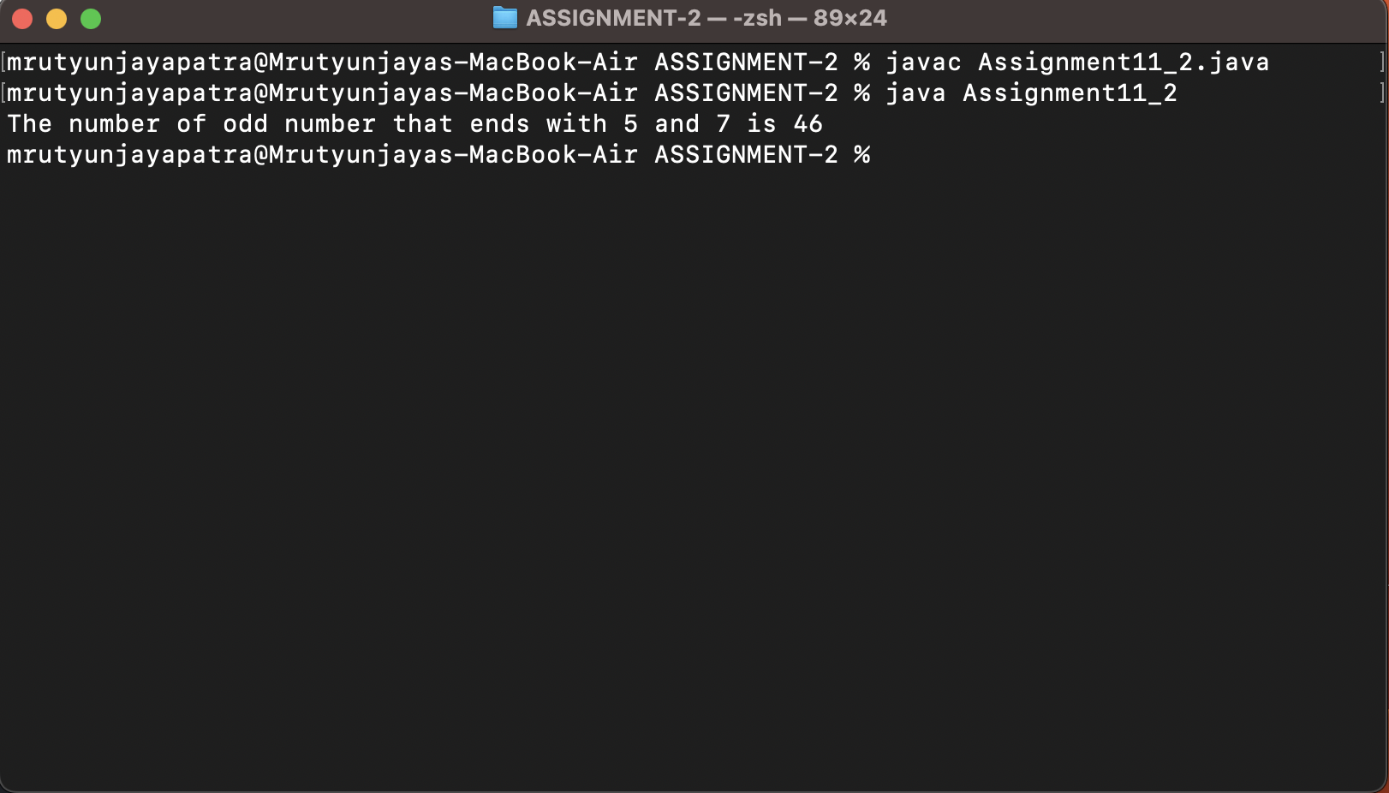  
c) find number of prime numbers?

public class Assignment11_3 {

public static void main(String[] args) {

int count=0,mcount=0;

for (int i = 24; i < 249; i++) {

for (int j = 1; j <=i; j++) {

if (i%j==0) {

count++;

}

}

if (count==2) {

System.out.println(i);

mcount++;

}

count=0;

}

System.out.println("The number of prime number is "+mcount);

}

}

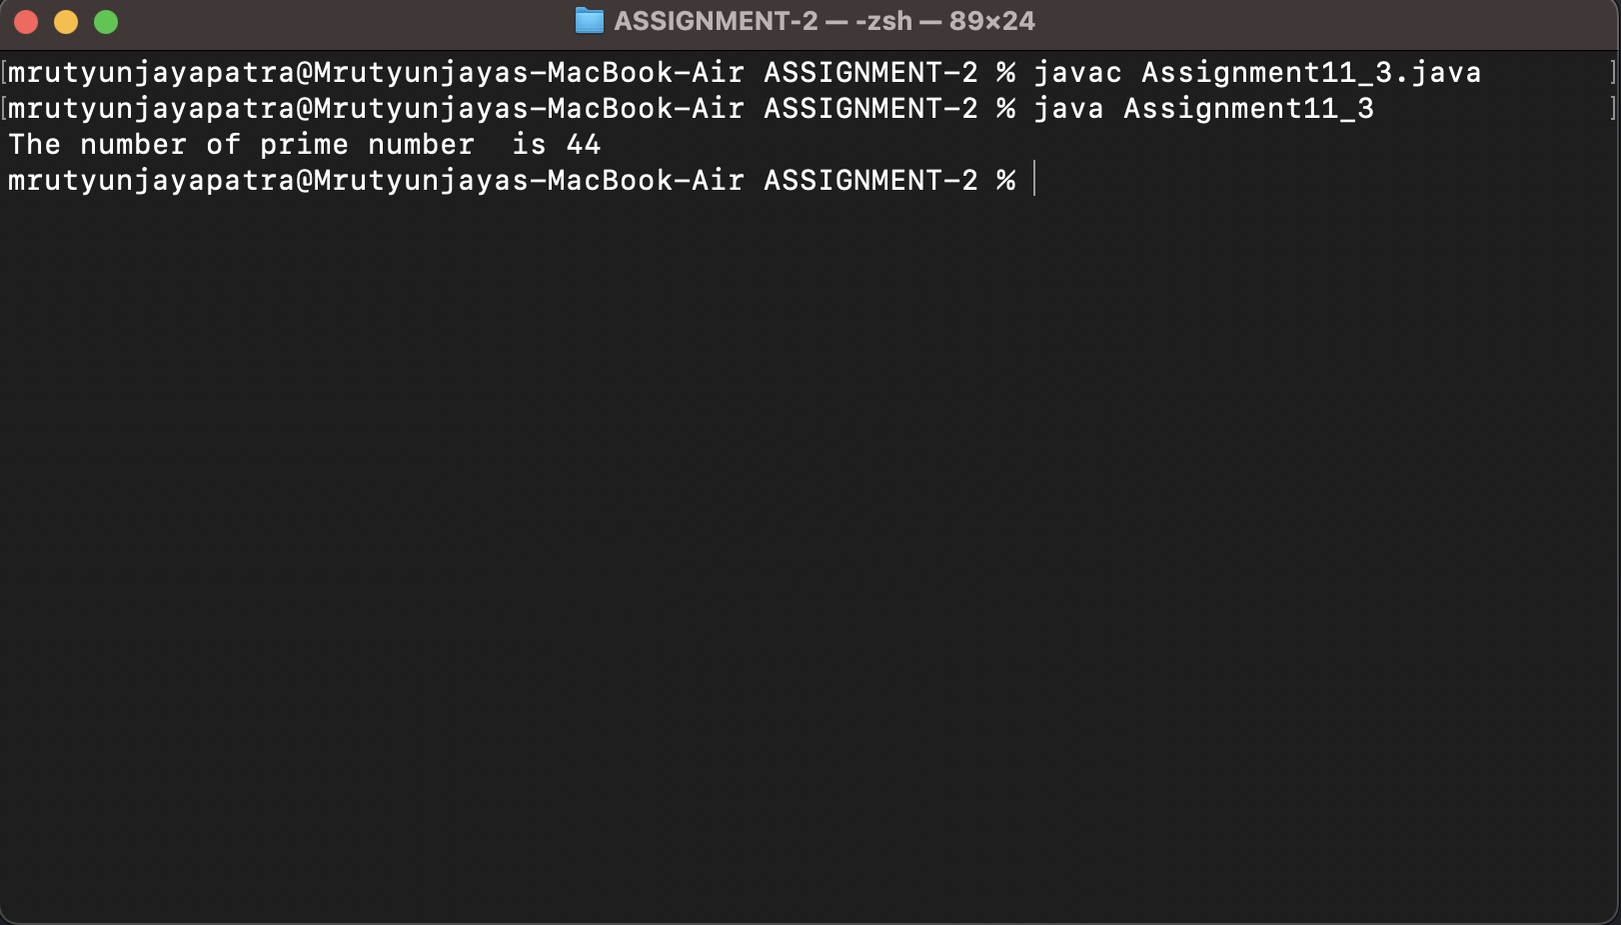

d) find number of palindrome numbers?

public class Assignment11_4 {

public static void main(String[] args) {

int r, count = 0, sum = 0, temp;

for (int i = 24; i < 249; i++) {

sum=0;

temp = i;

while (temp > 0) {

r = temp % 10; // getting remainder

sum = (sum * 10) + r;

temp = temp / 10;

}

if (i == sum) {

count++;

}

}

System.out.println("The number of palindrome number is " + count);

}

}

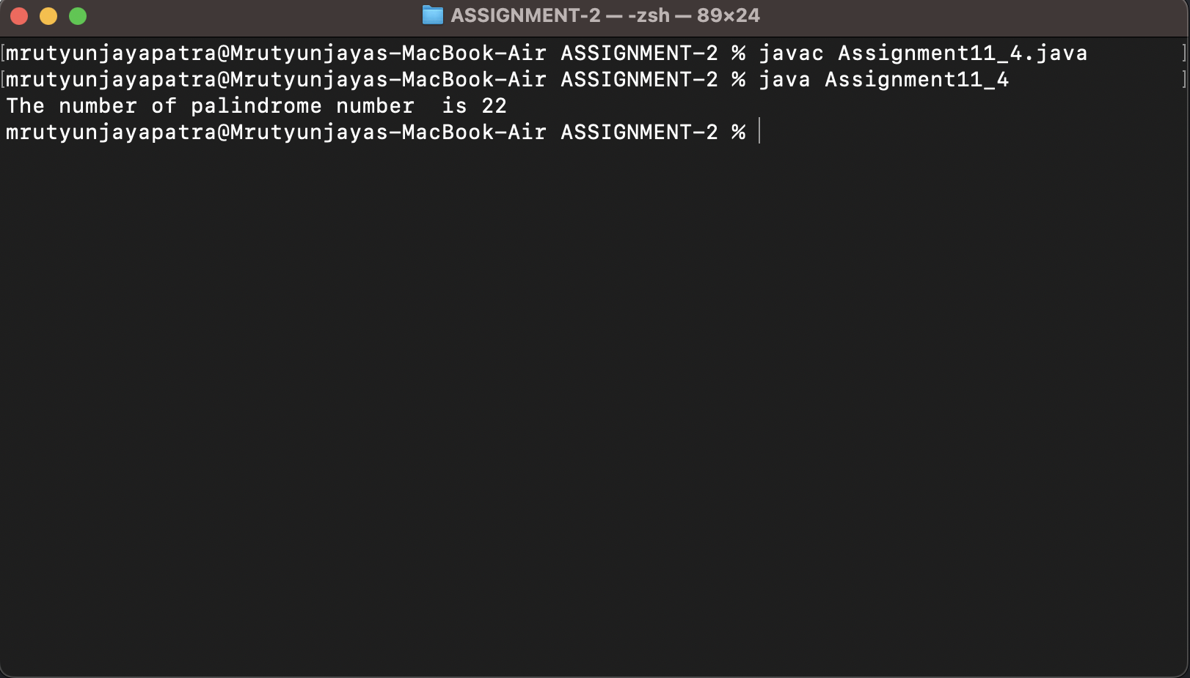

e) find difference between average of palindrome and prime numbers?

public class Assignment11_5 {

public static void main(String[] args) {

int temp,rem,rev=0,palcount=0,prcount=0,count=0;

int sumpal=0,sumpr=0;

for (int i = 24; i < 249; i++) {

count=0;

rev=0;

rem=0;

temp=i;

while (temp>0) {

rem=temp%10;

rev=rev*10+rem;

temp/=10;

}

if (rev==i) {

sumpal+=i;

palcount++;

}

for (int j = 1; j <=i; j++) {

if (i%j==0) {

count++;

}

}

if (count==2) {

sumpr+=i;

prcount++;

}

}

System.out.println("Difference between average of palindrome and prime numbers is :: "+((sumpal/palcount)-(sumpr/prcount)));

}

}

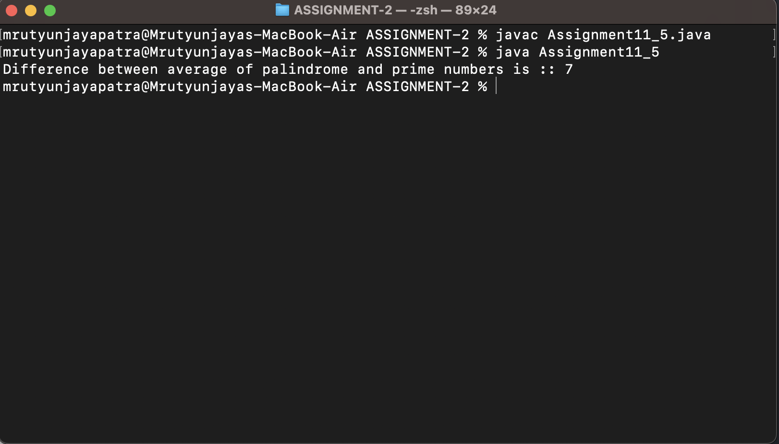

f) find GCD and LCM of all even numbers?

g) find GCD and LCM of all odd numbers?

h) Check whether the difference between largest even number and smallest odd number is palindrome or not?

public class Assignment11_8 {

public static void main(String[] args) {

int num, rem, rev = 0, temp;

int largest = Integer.MIN_VALUE;

int smallest = Integer.MAX_VALUE;

for (int i = 24; i < 249; i++) {

if (i % 2 == 0) {

if (i > largest) {

largest = i;

}

} else {

if (i < smallest) {

smallest = i;

}

}

}

num = largest - smallest;

temp = num;

while (temp > 0) {

rem = temp % 10;

rev = rev * 10 + rem;

temp = temp / 10;

}

if (rev == num) {

System.out.println("The difference between "+largest+" and ("+smallest+(largest-smallest)+") is a palindrome number");

} else {

System.out.println("The difference between "+largest+" and "+smallest+" (" +(largest-smallest)+") is not a palindrome number");

}

}

}

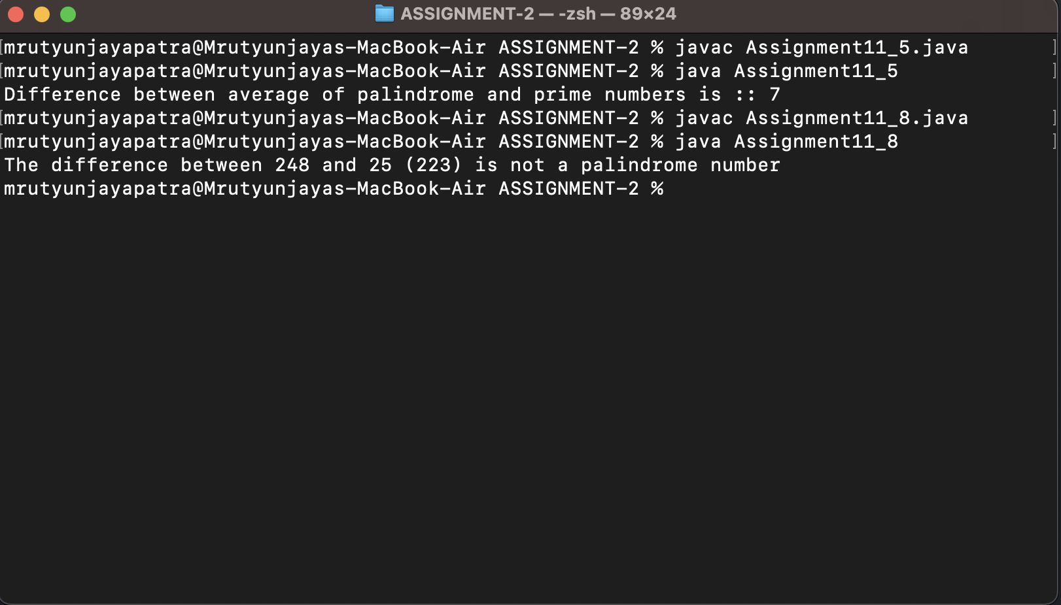

1. find first five largest even number and smallest odd number?

public class Assignment11_9 {

public static void main(String[] args) {

int count=0;

System.out.println("The first five largest even number");

for (int i = 24; i < 249; i++) {

if (i%2==0 && count<=5) {

System.out.println(i);

count++;

}

}

count=0;

System.out.println("The first five largest odd number");

for (int i = 24; i < 249; i++) {

if (i%2!=0 && count<=5) {

System.out.println(i);

count++;

}

}

}

}

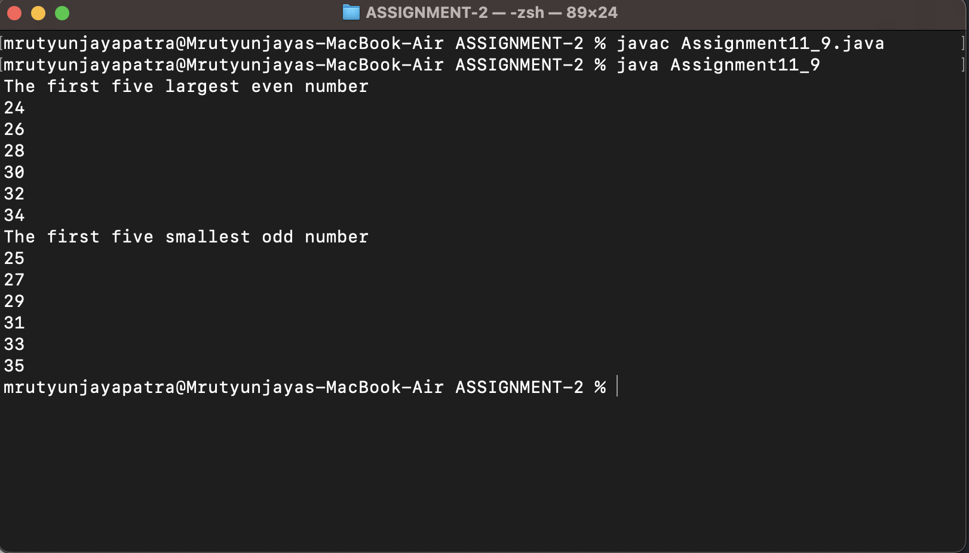

j) find the sum of product of corresponding digits of 2nd largest even number and 3rd smallest odd number?

public class Assignment11_10 {

public static void main(String[] args) {

int max1=Integer.MIN_VALUE;

int max2=Integer.MIN_VALUE;

int firstsmall=Integer.MAX_VALUE;

int secondsmall=Integer.MAX_VALUE;

int thirdsmall=Integer.MAX_VALUE;

for (int i = 24; i < 249; i++) {

if (i%2==0) {

if (i>max1) {

max2=max1;

max1=i;

}else if(i>max2 && max1<i){

max2=i;

}

}else if(i%2!=0){

if (i<firstsmall) {

thirdsmall=secondsmall;

secondsmall=firstsmall;

firstsmall=i;

}else if(i<secondsmall && firstsmall>i){

secondsmall=i;

}else if (i<thirdsmall && secondsmall>i) {

thirdsmall=i;

}

}

}

System.out.println(firstsmall);

System.out.println(secondsmall);

System.out.println(thirdsmall);

}

}

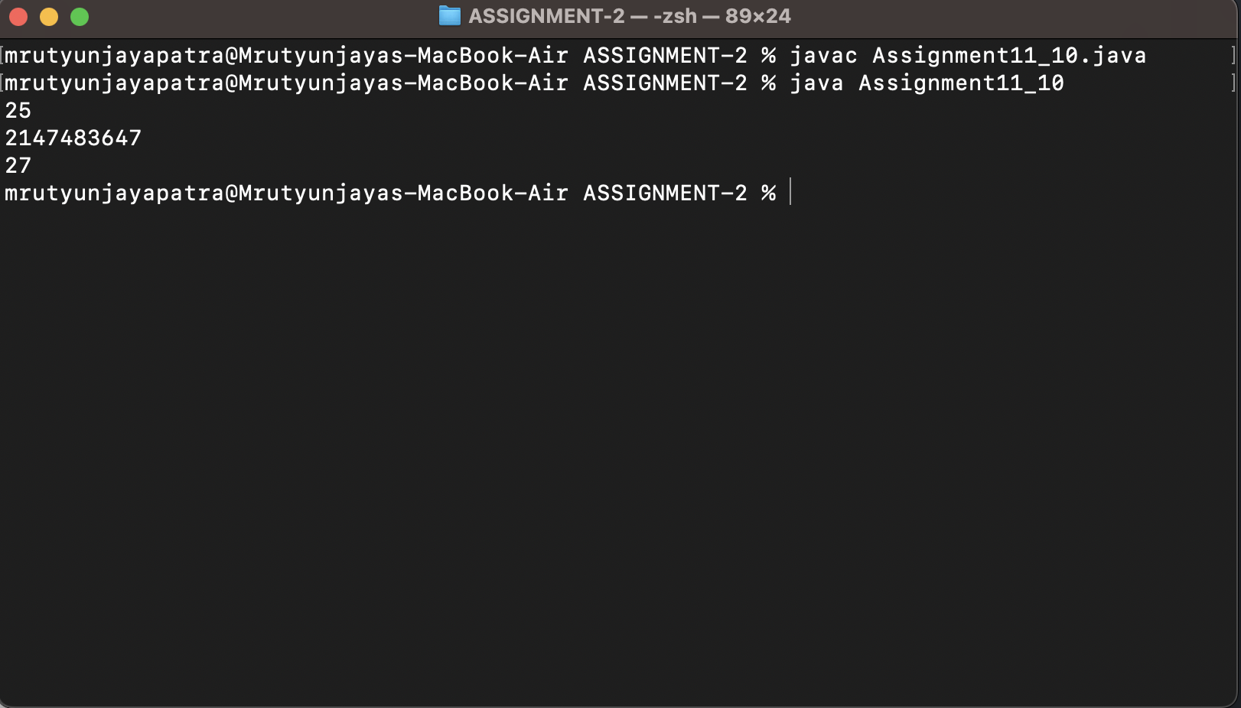

1. Write a java program to find following of 10 numbers using command line arguments? Do not use array?
2. find difference between greatest and smallest number?

public class Assignment12_1 {

public static void main(String[] args) {

int largest=Integer.MIN_VALUE,smallest=Integer.MAX_VALUE;

int temp;

for (int i = 0; i < args.length; i++) {

temp=Integer.parseInt(args[i]);

if (temp>largest) {

largest=temp;

}

if (temp<smallest) {

smallest=temp;

}

}

System.out.println("The difference between largest and smallest number is "+(largest-smallest));

}

}

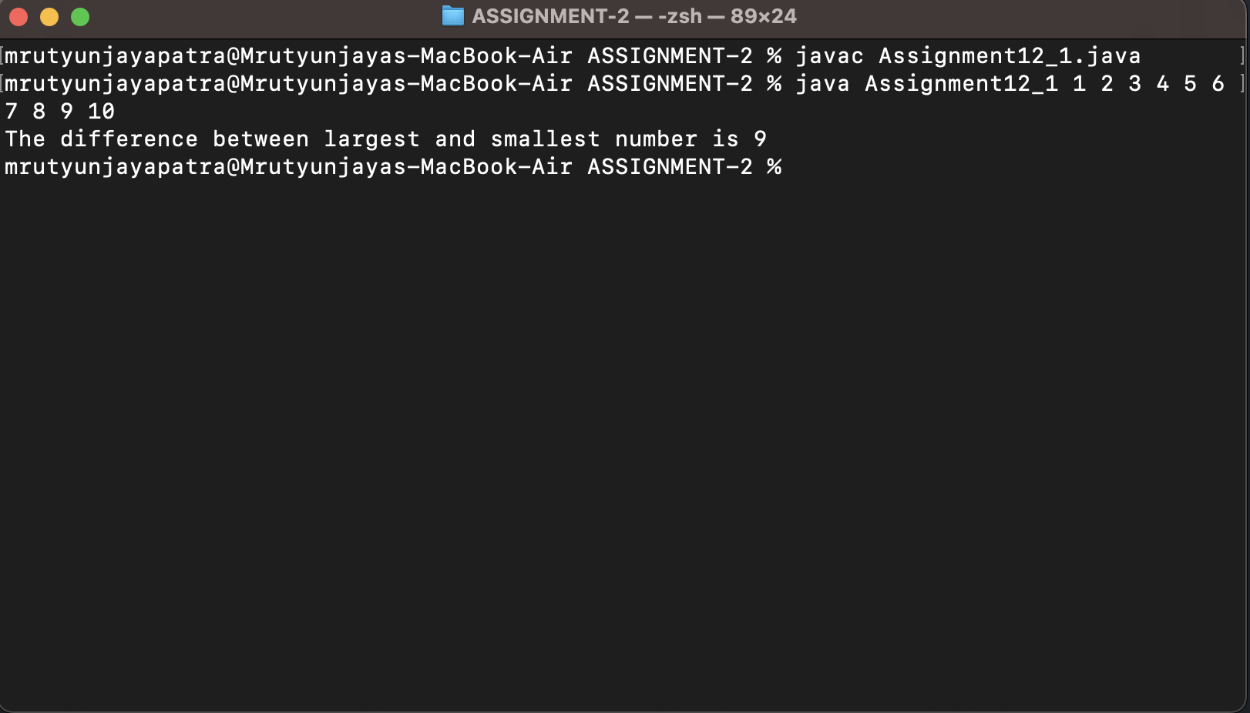  
b) find difference between average of all odd numbers and even numbers?

public class Assignment12_2 {

public static void main(String[] args) {

int s_even=0,s_odd=0,ecount=0,ocount=0;

for (int i = 0; i < args.length; i++) {

int temp=Integer.parseInt(args[i]);

if (temp%2==0) {

s_even+=temp;

ecount++;

}else {

s_odd+=temp;

ocount++;

}

}

System.out.println(ecount);

System.out.println(s_even);

System.out.println(s_odd);

System.out.println("Difference between average of all odd numbers and even numbers is :: "+((s_even/ecount)-(s_odd/ocount)));

}

}

